**SAVEETHA SCHOOL OF ENGINEERING**

**SAVEETHA INSTITUTE OF MEDICAL AND TECHNICAL SCIENCES**

**INSTITUTE OF PLACEMENT AND TRAINING**

**CSA0987 –JAVA PROGRAMMING**

**NAME:M.DEEPIKA**

**REG.NO:192311027**

**ASSIGNMENT:3**

1. Write a program to print the following pattern

Sample Input:

Enter the Character to be printed: %

Max Number of time printed: 3

%

% %

% % %

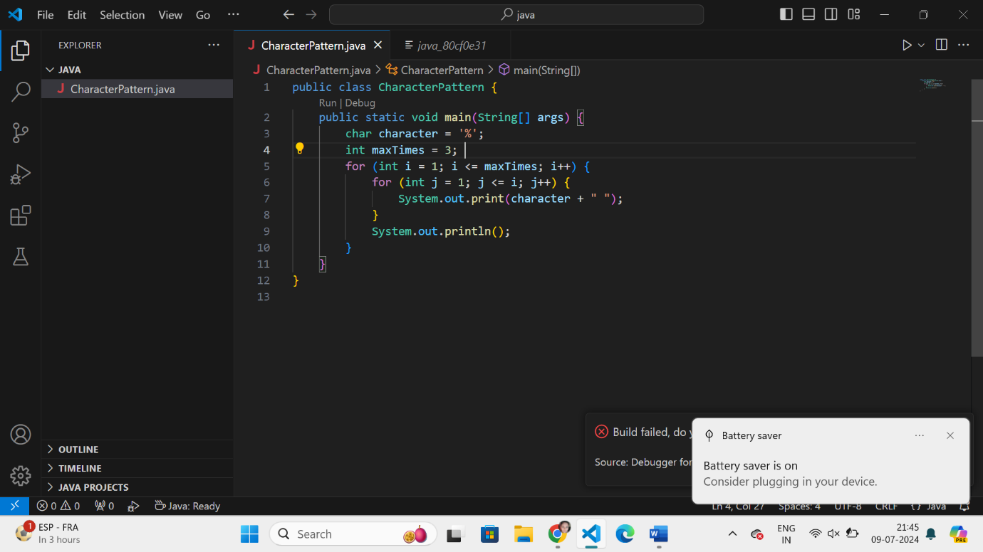

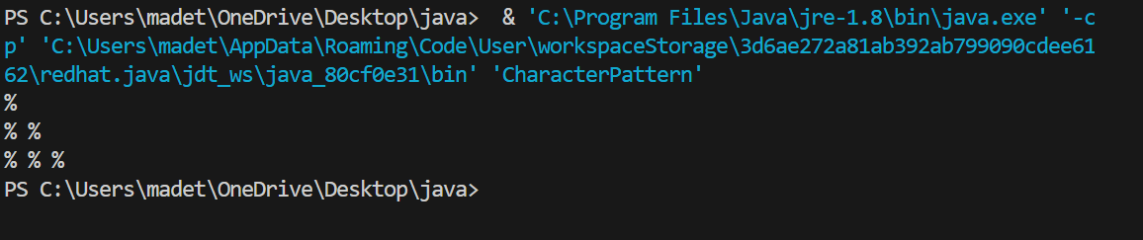

1. Write a program to print hollow square symbol pattern?

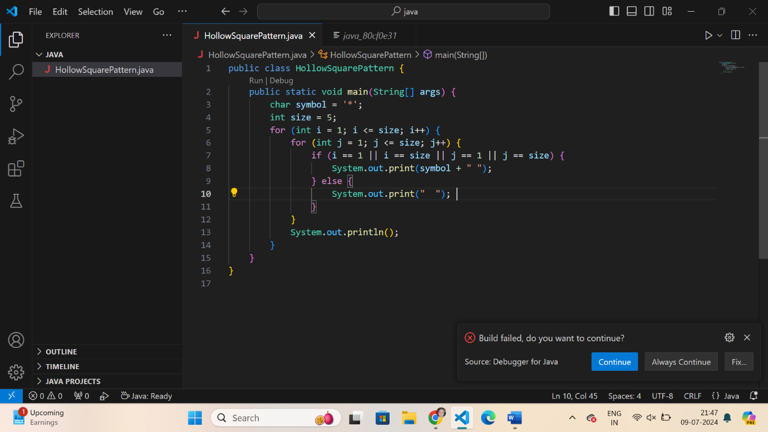

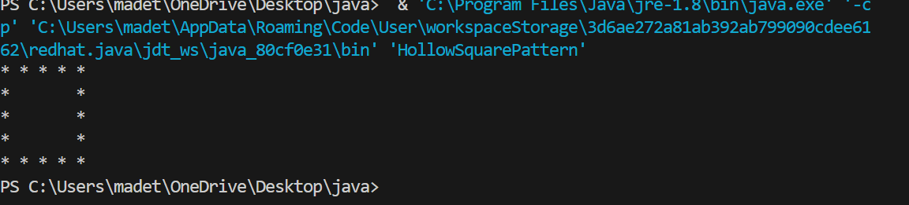

1. Write a program to print the below pattern

1

2 2

3 3 3

4 4 4 4

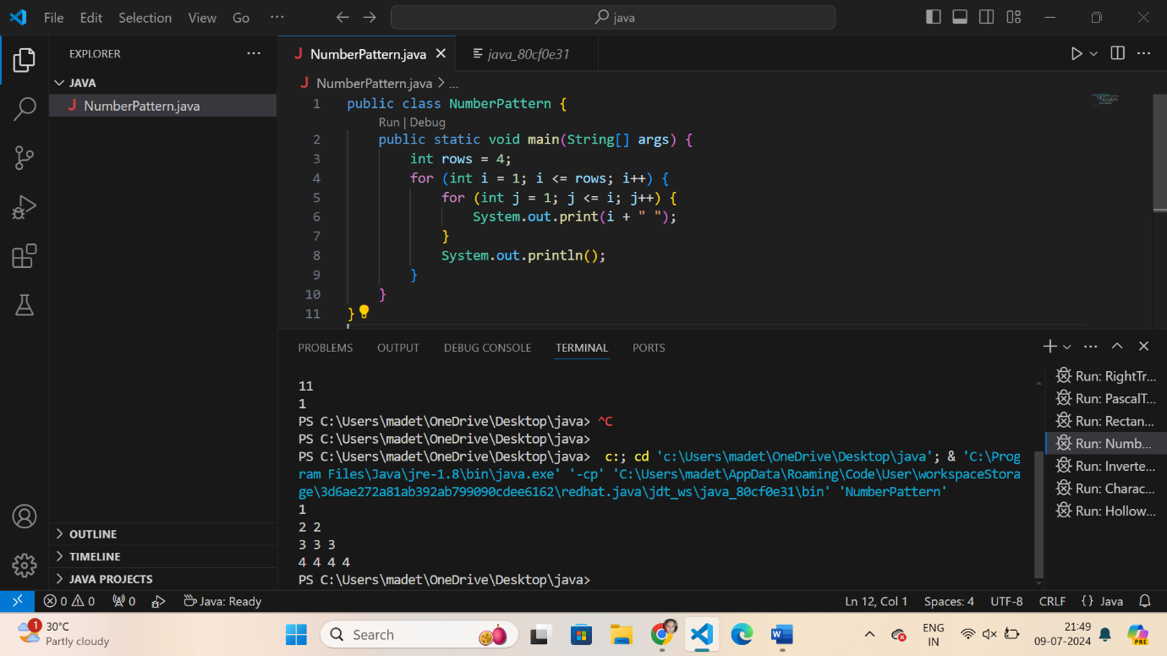

1. Write a program to print the below pattern

1

4 9

16 25 36

49 64 81 100

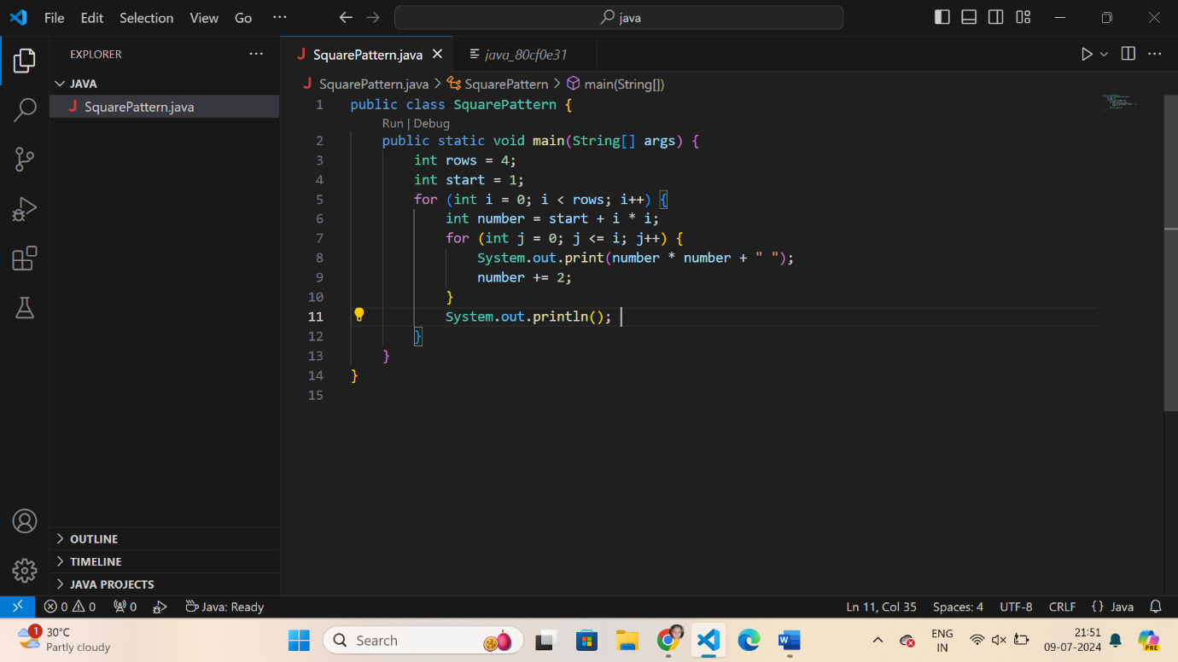

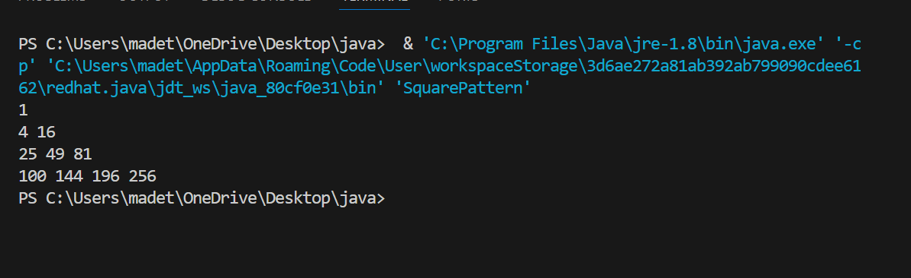

1. Write a program to print the below pattern

1

2 2

3 3 3

4 4 4 4

3 3 3

2 2

1

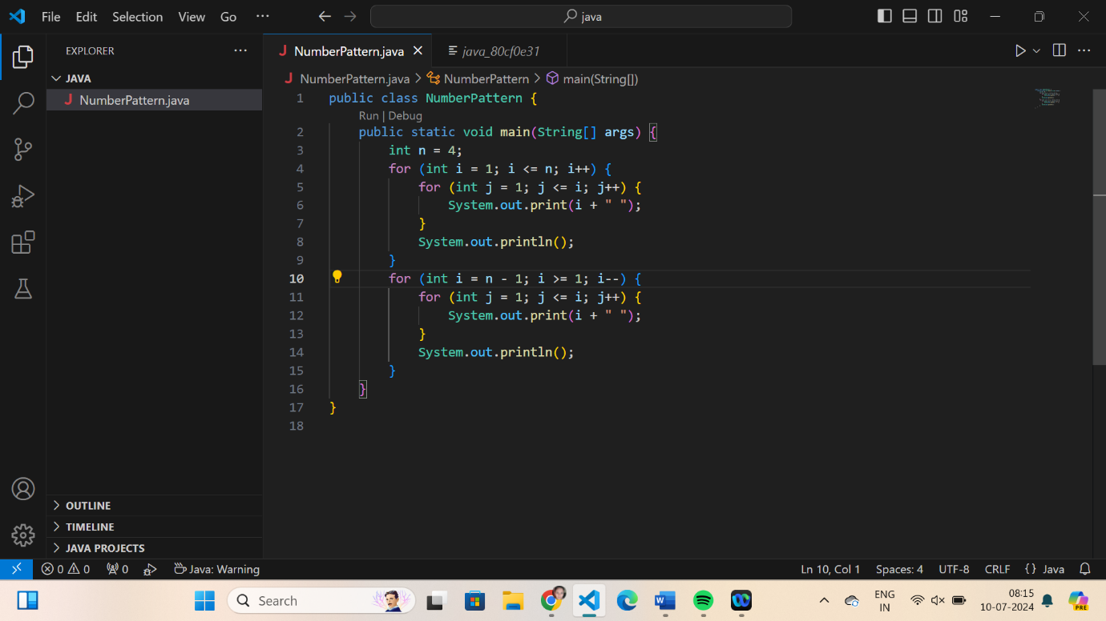

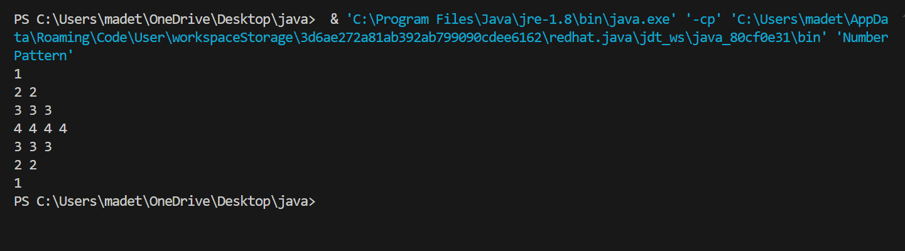

1. Write a program to print hollow Square Dollar pattern?

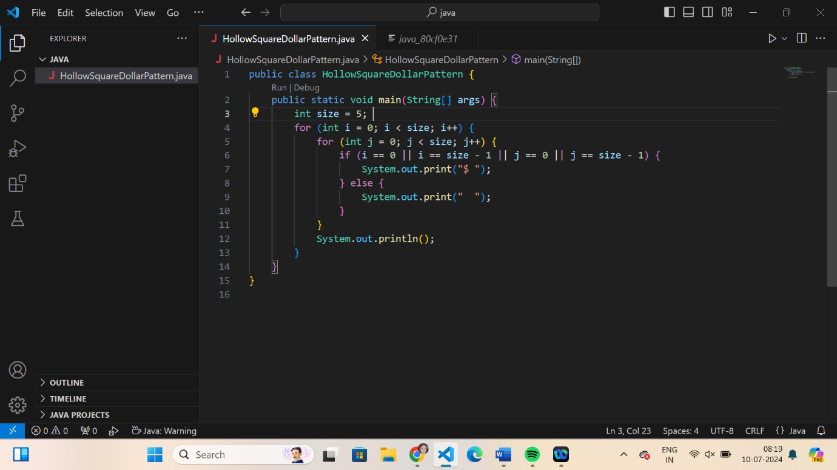

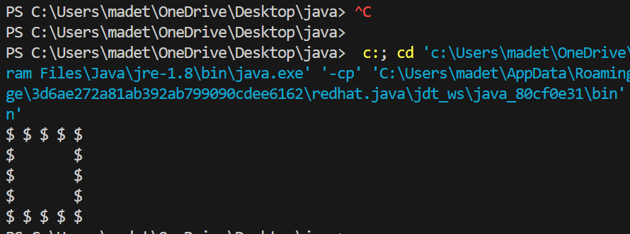

1. Write a program to print inverted pyramid pattern.

Input: no of rows: 3

Output

*****

***

*

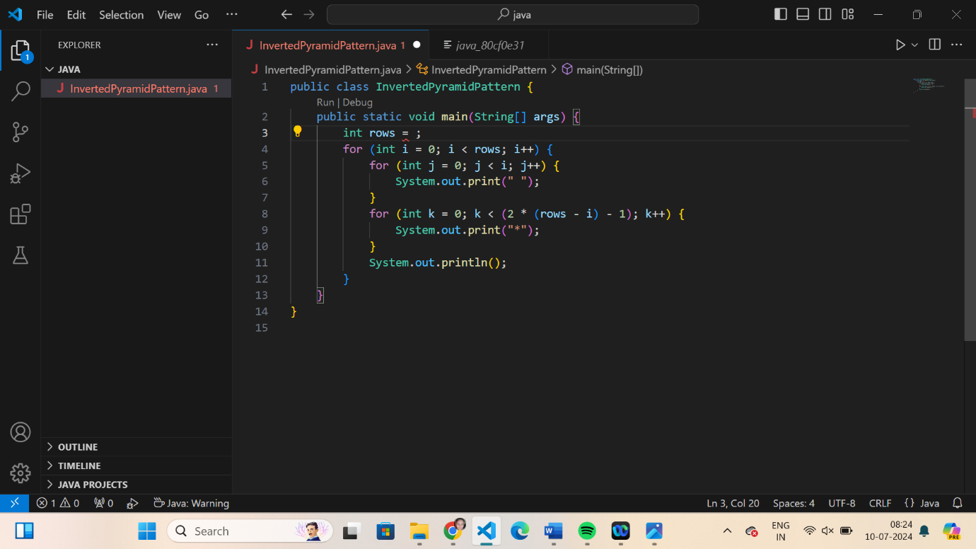

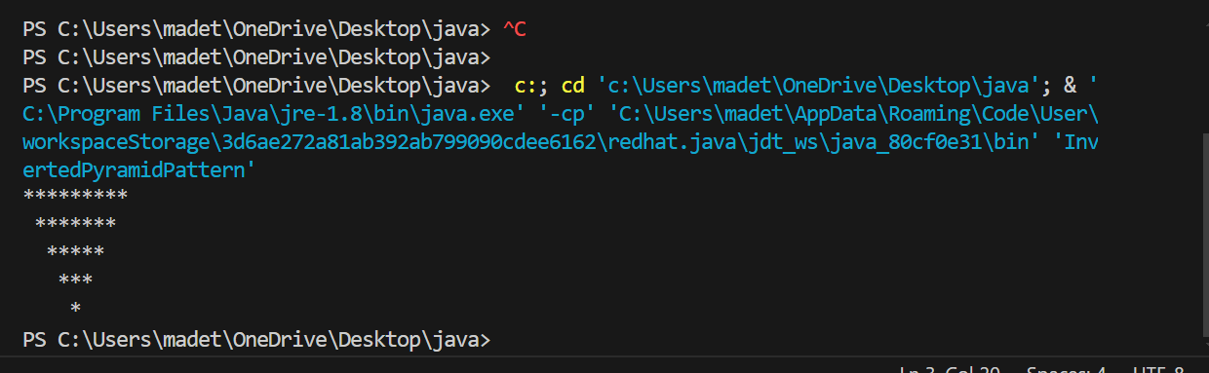

**General:**

1. Write a program to reverse a number using loop?(Get the input from user)

Sample Input:

Number: 14567

Sample Output:

Reverse Number: 76541

Test cases:

1. -45721
2. 000
3. AD1947
4. !@#$%
5. 145*999=144855

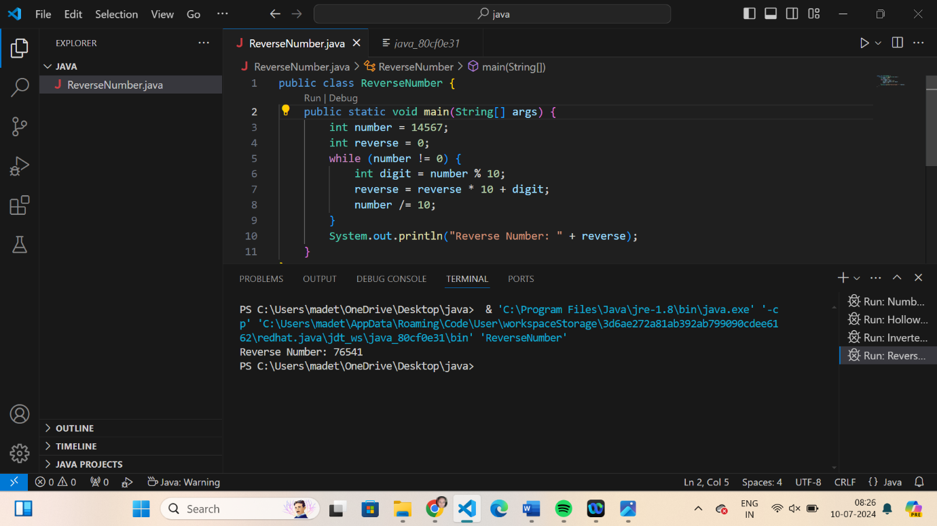

1. Write a program to convert the given decimal to binary and print the reverse of the binary decimal.

Input: 11

Output: 13

Explanation: (11)10 = (1011)2.

After reversing the bits we get:

(1101)2 = (13)10.

Test cases:

1. 25
2. Eighteen
3. 12
4. -18
5. 34.5

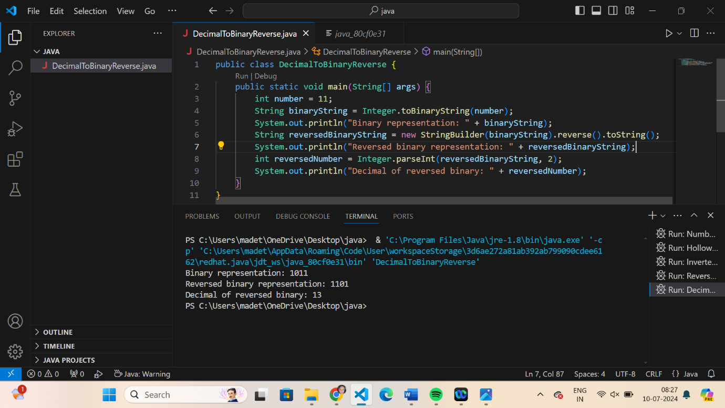

1. Write a program to find whether the person is eligible for vote or not. And if that particular person is not eligible, then print how many years are left to be eligible.

Sample Input:

Enter your age: 7

Sample output:

You are allowed to vote after 11 years

Test cases:

1. 25
2. Eighteen
3. 12
4. -18
5. 34.5

